Java If-else Statement (Page No.78)
The Java if statement is used to test the condition. It checks boolean condition: true or false. There are various types of if statement in java.
- if statement
- if-else statement
- nested if statement
- if-else-if ladder

Java IF Statement
The Java if statement tests the condition. It executes the if block if condition is true.
Syntax:
- if(condition){
- //code to be executed
- }
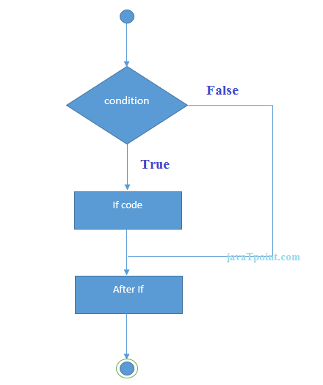
Example:
- public class IfExample {
- public static void main(String[] args) {
- int age=20;
- if(age>18){
- System.out.print("Age is greater than 18");
- }
- }
- }
Output:
Age is greater than 18

Java IF-else Statement
The Java if-else statement also tests the condition. It executes the if block if condition is true otherwise else block is executed.
Syntax:
- if(condition){
- //code if condition is true
- }else{
- //code if condition is false
- }
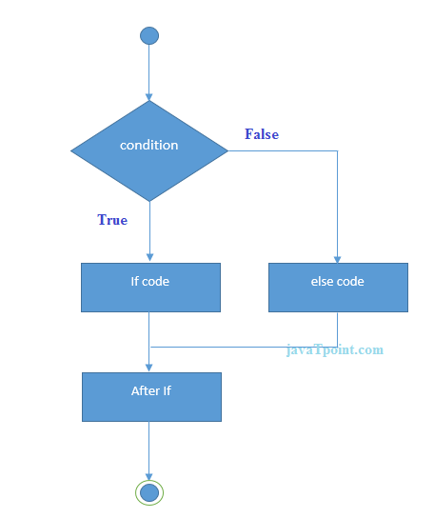
Example:
- public class IfElseExample {
- public static void main(String[] args) {
- int number=13;
- if(number%2==0){
- System.out.println("even number");
- }else{
- System.out.println("odd number");
- }
- }
- }
Output:
odd number

Java IF-else-if ladder Statement
The if-else-if ladder statement executes one condition from multiple statements.
Syntax:
- if(condition1){
- //code to be executed if condition1 is true
- }else if(condition2){
- //code to be executed if condition2 is true
- }
- else if(condition3){
- //code to be executed if condition3 is true
- }
- ...
- else{
- //code to be executed if all the conditions are false
- }
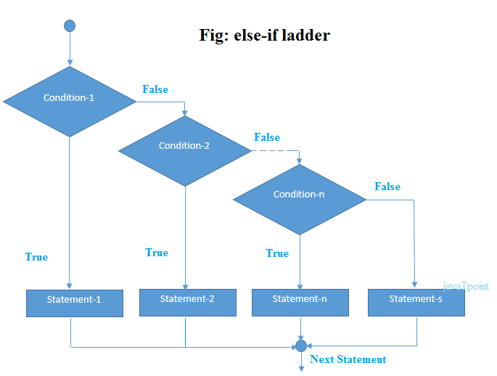
Example:
- public class IfElseIfExample {
- public static void main(String[] args) {
- int marks=65;

- if(marks<50){
- System.out.println("fail");
- }
- else if(marks>=50 && marks<60){
- System.out.println("D grade");
- }
- else if(marks>=60 && marks<70){
- System.out.println("C grade");
- }
- else if(marks>=70 && marks<80){
- System.out.println("B grade");
- }
- else if(marks>=80 && marks<90){
- System.out.println("A grade");
- }else if(marks>=90 && marks<100){
- System.out.println("A+ grade");
- }else{
- System.out.println("Invalid!");
- }
- }
- }
Output:
C grade

Switch Branch (Page no.86)

The switch branch evaluates a single variable then executes a statement according to the variable’s value. Primitive data types byte, short, char, and int are evaluated along with String. The switch and if branches have similar functionality. There are situations where either branch is suitable. However, the switch branch is most efficient when dealing with a specific number of values, such as days of the week. Otherwise, it is best to implement an if branch when handling an infinite number of values.
The following is the syntax for the switch branch:

Syntax

switch (variableName)

{

case constant1:

statement(s);

break;

case constant2:

statement(s);

break;

case constant3:

statement(s);

break;
--
--
default:

statement(s);

}

Example:

public class SwitchCaseDemo {
public static void main(String[] args) {
char Grade ='B';
switch (Grade)
{
case 'A':
System.out.println("Grade A :"+ 2000);
break;
case 'B':
System.out.println("Grade A :"+ 1000);
break;
case 'C':
System.out.println("Grade A :"+ 500);
break;
default:
System.out.println("Grade A :"+ 100);
break;
}
}
}

Nested switch Statements
You can use a switch as part of the statement sequence of an outer switch. This is called a nested switch. Since a switch statement defines its own block, no conflicts arise between the case constants in the inner switch and those in the outer switch.
Important Points related to Switch-Case statements:
- The switch can only check for equality. This means that the other relational operators such as greater than are rendered unusable in a case.
- Case constants are evaluated from the top down, and the first case constant that matches the switch's expression is the execution entry point. If no break statement used, all the case after entry point will be executed.
- No two case constants in the same switch can have identical values. Of course, a switch statement and an enclosing outer switch can have case constants in common.
- The default case can be located at the end, middle, or top. Generally, default appears at end of all cases.

Break Statements
The break statement included with each case section determines when to stop executing statements in response to a matching case. Without a break statement in a case section, after a match is made, the statements for that match and all the statements further down the switch are executed until a break or the end of the switch is found. In some situations, this might be exactly what you want to do. Otherwise, you should include break statements to ensure that only the right code is executed. It is sometimes desirable to have multiple cases without break statements between them.
Summary
- The switch statement is Java’s multi-way branch statement.
- The switch can only check for equality. This means that the other relational operators such as greater than are rendered unusable in a case.
- The break statement is used to stop current iteration of loop or end Switch-case block.

For Loop (Page no.90)

The for loop executes a block of code for a certain number of iterations. In other words, a statement executes as long as a condition is met. One of the benefits allows statements to execute without writing code repeatedly. The following is the for loop syntax:

Syntax

for (initialization; condition; iteration)
{
statement(s);
}

Syntax Details Argument | Description
for | Keyword that starts the for loop
initialization | Assignment that sets the loop control initial value
; | Semi-colon completes the initialization
condition | A boolean expression that determines if the loop will or will not repeat
; | Semi-colon completes the condition
iteration | Indicates how the loop control variable will change after each variation
{ | An opening curly bracket
statement(s) | Statement(s) that will execute after the condition is met
; | Semi-colon completes the statement
} | A closing curly bracket

While Loop (Page no.93)

The while loop repeats a statement while a condition is true. Conditions are boolean expressions that is checked prior to executing the statement. In addition, the variable name initialized before the loop and evaluated as part of the condition. statement, the while loop continues until the condition becomes false. The following is the syntax of a while loop.

Syntax

while (condition)

{
statement(s);
}

Syntax Details Argument | Description
while | Keyword that starts the loop
condition | A boolean expression that determines if the loop will or will not repeat
{ | An opening curly bracket
statement(s) | Statement(s) that will execute after the condition is met
; | Semi-colon that completes the statement
} | A closing curly bracket

Do While Loop (Page no.96)
The do while loop evaluates a condition at the bottom of the loop. Therefore, the loop will execute the statement within the loop then evaluate the condition. As a result, the do while loop always executes a statement at least one iteration and continues as long as the condition is true.

The following is the syntax for a do while loop:

Syntax

do
{
statement(s);
}
while (condition);

Syntax Details Argument | Description
do | Keyword that starts the loop
{ | An opening curly bracket
statement(s) | Statement(s) that will execute at least once
; | Semi-colon that completes the statement
} | A closing curly bracket
while | Keyword that determines if the loop’s condition will repeat
condition | A boolean expression that determines if the loop will or will not repeat
; | Semi-colon that completes the condition

